**Group-6(Members)**

Sreesatya Desaraju (AP18110010422)

Maganti Vijaya Durga (AP18110010456)

J. Sundar Ganesh (AP18110010452)

**DBMS Project**

**ONLINE COURSE MANAGEMENT SYSTEM**

**ABSTRACT:**

**Online Course Management System** Software is an online management application, built as a software development project in Java programming language. Its main purpose is making efficient interaction between students and instructors in college during the period of submission of assignments, projects, thesis, and for getting appropriate feedback from instructors.

This Project Divided into two modules

* Admin
* Student

Admin—–Admin will register the student and provide username,password and pin code.Pin Code will be used when a student enrolls for the course. Admin can manage sessions,semester,departments,course,students,students log.

One of the major goals of this software project is academic use; it can be used as a reference to your final year project as well as to learn about software development in Java. The source code of Course Management System is written in Java, and it can be downloaded from the links provided in this post.

**OBJECTIVE:**

Learning abilities vary among individuals, but they are taught by schools in one schoolroom. Managing learning skills could be daunting. This Web Course management framework incorporates learning methods that solve this problem. Therefore, the purpose of this work is to establish an adaptive approach to encourage the learner to answer questions or solve problems, e-learning software, on the basis of his / her abilities. This work is driven by the need to tackle deeply Knowledge and concern for how learners learn best. Creation of this study develops an adaptive e-learning platform where the learner can answer questions based on his / her skill or speed or solve problems. Also, it provides an online classroom that runs next to the conventional classroom. This adopts a waterfall model which will be implemented by machines.

The objective of this work is to create an adaptive software for e-learning to allow the based on his / her skill or speed, the learner will answer questions or solve problems.

The goals of this research are:

1) Build web-based tools to administer courses for learners.

2) Incorporate a function that will enable learners to schedule reminders for

Their missions or assessments.

3) Build a function that will be used to ensure that all levels of

There is coverage for learning.

4) Develop and incorporate a feature that will allow students to answer questions based on their assessment learning skills.

MOODLE is a free software package intended to assist lecturers and learners. It is a tool for providing quality teaching. MOODLE is short for Modular Martin Douglas 's Object Based Dynamic Learning Environment. Moodle has a variety of educational advantages. MOODLE is straightforward to instal, update and use. It can be installed without installation on as many servers as possible. A supplemental expense. Also, MOODLE does not need changes to Unix, Linux, Mac OS, Windows and any other systems. It is applied for training purposes Elements that are missing in several other e-learning platforms.

**CHALLENGES FACED BY E-LEARNING:**

If E-Learning in any country, place or institution is to live up to its expectations, it is Technological, social, and pedagogical aspects must be overcome, including a change in attitude. Before introducing E-Learning, these restraints must be overcome.

The problems are as follows,

1. Technological aspect.
2. Social aspect.
3. Pedagogical aspect: aspect of the mindset.
4. Lack of face-to - face communication.
5. Challenges of professional training.

**ADVANTAGES OF E-LEARNING:**

1) Flexibility.

2) Convenience.

3) Methods to e-learning.

4) Self-paced e-learning.

5) E-learning guided and facilitated by instructors

**PROPOSED SYSTEM:**

When introduced, this new system would do the following things:

1) Ensure that student assessment is not out of context, and cover the three learning realms.

2) Handle the courses of learners efficiently.

3) Incorporate a function that will enable learners to schedule reminders for their missions or assessments.

4) Build a function that will be used to ensure that all levels of learning is discussed in a course.

5) Make sure students answer questions based on their ability to understand assessments.

**HARDWARE REQUIREMENTS:**

1) A hard disc drive of approximately 80 (GB) and above.

2) A processor with a Pentium M (2.0 GHz).

3) A computer with a flat screen.

4) A minimum of 1.0 GB of RAM and above.

5) A keyboard that has been improved.

6) With a PRINTER.

7) A UPS system.

8) Flash drives for file backups

**SOFTWARE REQUIREMENTS:**

1)An Operation system, Microsoft Windows (XP, 7 or 8).

2) Dot Net framework 3.0, 3.5, 4.0 or 4.5.

3) Reliable antivirus software.

4) MySQL Database program.

**TECHNOLOGY USED:**

HTML, AJAX,JQUERY,JAVASCRIPT, PHP5.6, PHP7.x

**DETAILS HANDLED:**

This project's following features have made it more user-friendly, effective, and safe:

1. It allows each student to be granted an individual user account by the college or university.
2. Both user accounts are password protected (instructors and students). Therefore, the database can be classified as protected.
3. Only the administrative section is permitted to establish an account in the Online Course Management System, but students and instructors can register with the application.
4. Using the SQL query, the user may view his or her information after creating the account.

**SAMPLE SCENARIOS:**

In the 21st century, the traditional approach of sending tasks, assignments, theses, etc. is not so successful. Students must visit college within the current framework and make an appointment with the teacher. The student is only expected to reach the teacher within a short amount of time after having the date and time, which is not enough to unravel all the problems.

Therefore, the use of computer-based systems for both students and teachers are clearly more productive and advantageous. The intent of this Online Course Management System is to connect students and instructors electronically through the Internet service with regard to their course activities.

There should be clear contact between students for submitting assignments and homework, tasks, and thesis for each education or course and obtaining feedback. Students need to meet faculty in this exciting method and nominate faculty or instructors to send work.

Considering every single quality factor, the system has been developed. The system is highly safe from the downside crash because of this factor. In addition, the system is very secure and due to security features, allows for the system of course management, unauthorised users are unable to access the system.

**WHO CAN USE THIS APPLICATION IN REAL LIFE:**

The Student Module and the Teacher Module are designed to allow students and instructors to log in to an administrator-created account and exchange information. With the application, students can register and submit their homework. Whereas instructors will review the homework of students and assign grades for their job.

The online course portal project is being built on the JavaScript and MySQL platform. The main objective of this framework is to introduce an online-based platform that can be useful for faculty students, mainly with education data. Online education is one of the fast-growing fields on the internet where users can directly solve problems by visiting websites with no academics facilitating them. The scope of online education and online courses was exaggerated by this approach.

**ALGORITHM:**

1. Login page: Page created to enter the credentials of the user.
2. Student page: Students can login with a valid registration number provided by the admin.
3. Students enroll for any given course.
4. Admin can change the password.
5. Students can view their course enrollment history.
6. Students can access their personal profile by doing so that has their personal details along with their CGPA and profile photo.
7. Students can change and update their details.
8. Then the website leads to the logout page.

**ERD diagram for the same:**

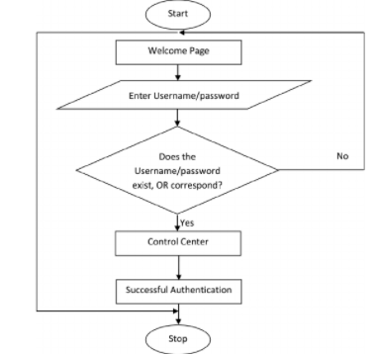

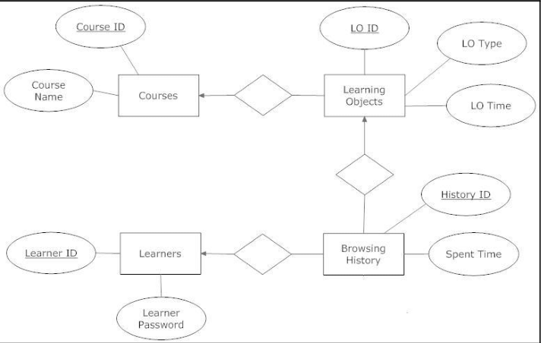

**OUTPUT Screenshots:**

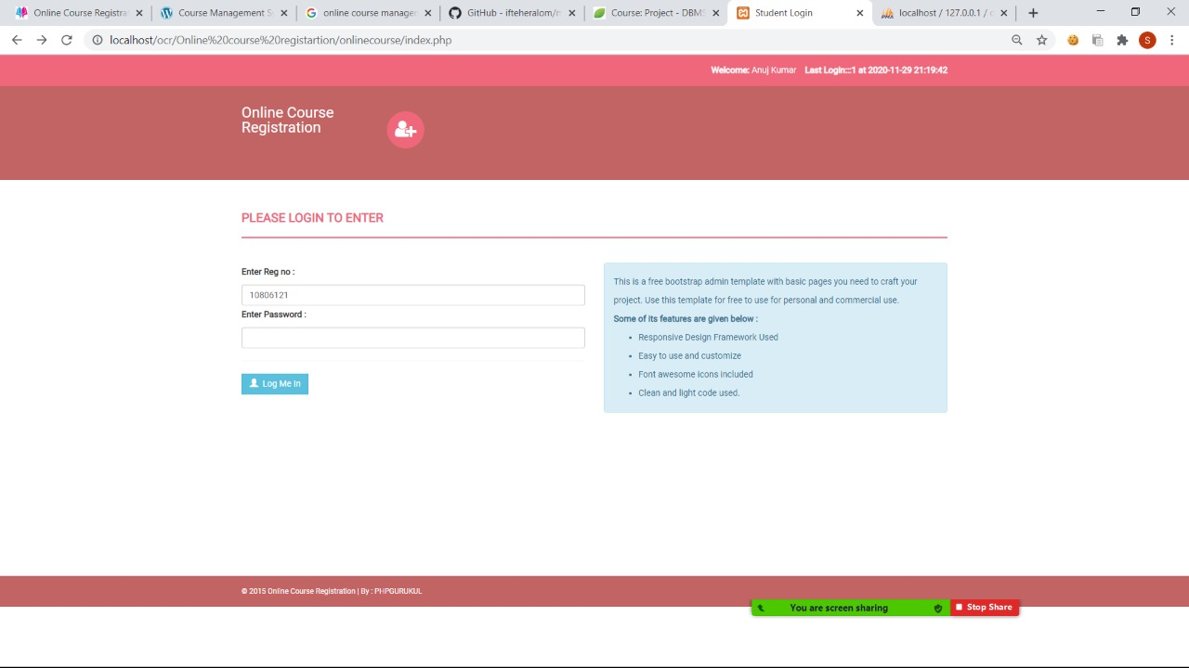

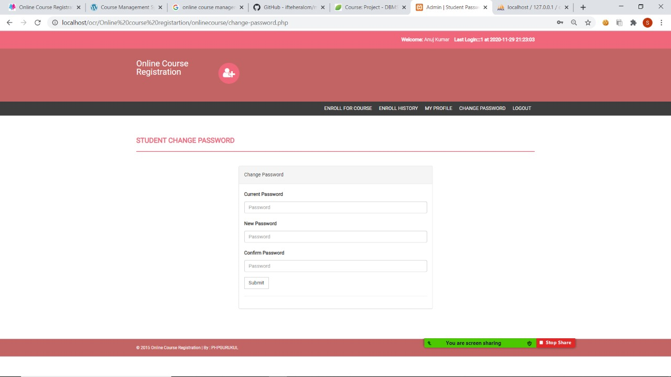

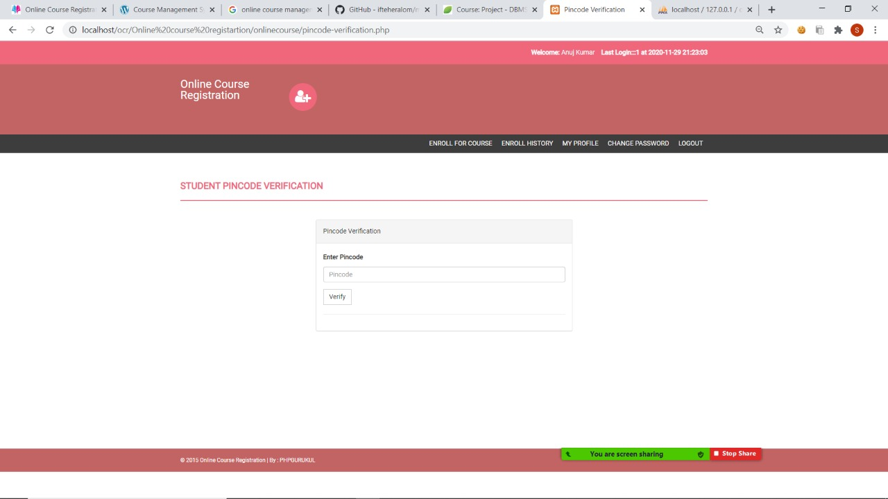

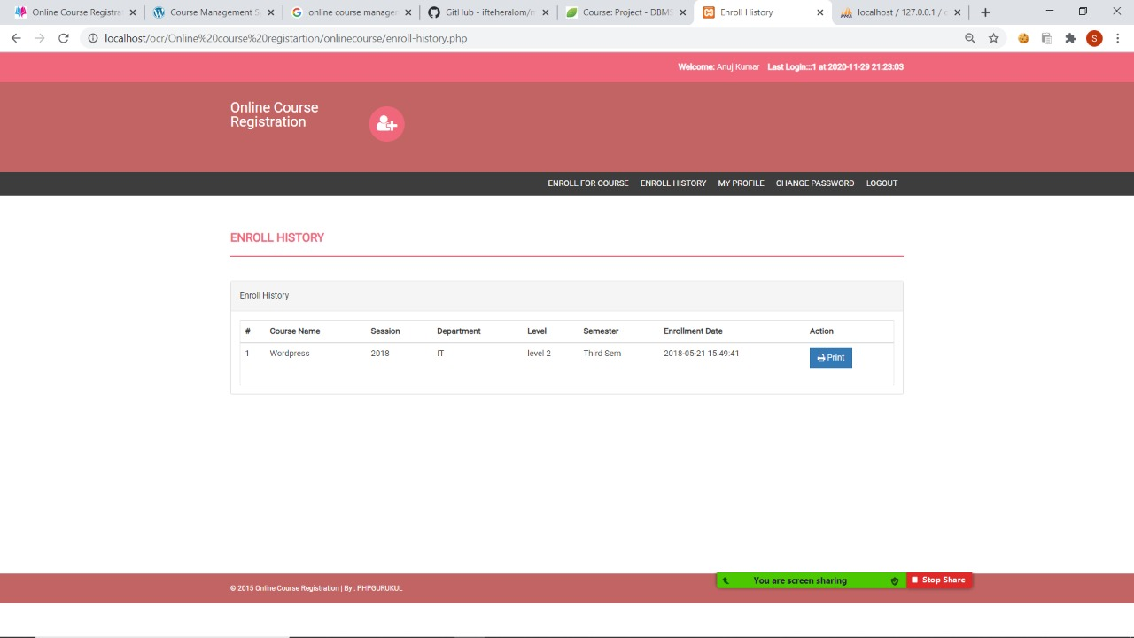

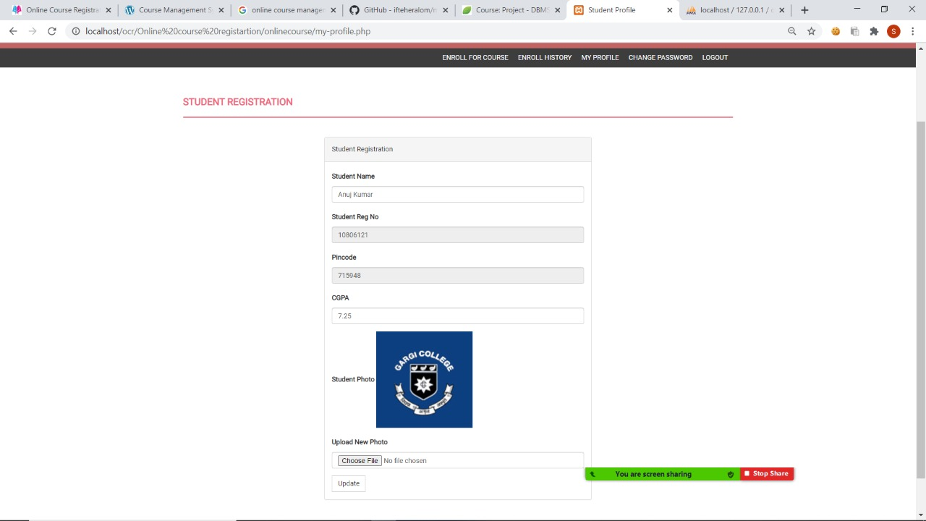

**TABLES:**

